WEEK 2
World Bank API
Unlike the Comtrade API, the World Bank API is free, open, and does not require an API key. It connects to multiple World Bank databases (like World Development Indicators) and allows you to fetch data for hundreds of countries and thousands of indicators in a few lines of code.
Installation: pip install wbgapi
Code Snippet:
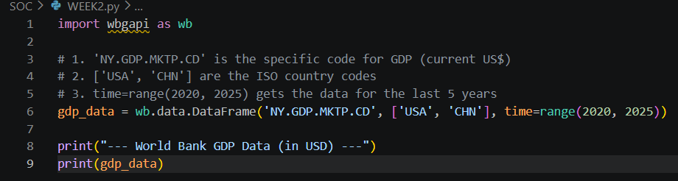
Output:
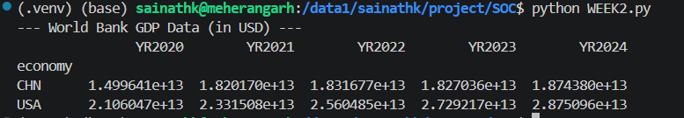
Above output shows the shows the GDP of China and USA over the period of 5 years(i.e. from 2020 to 2024)

Lead Time
Lead time is the total latency between the moment a customer places an order (the "deal") and the moment that order is fulfilled (the "shipment" or "delivery"). It is not a single number; it is a calculation of several sequential steps.

1. The Components of Lead Time
To calculate the delay, you have to break the process down. Lead time is the sum of these five stages:
- Procurement Lead Time: The time from placing an order to the supplier confirming it.
- Production Lead Time: The time required to manufacture or prepare the goods.
- Transit Lead Time: The time goods spend on ships, trucks, or planes.
- Customs/Clearance Lead Time: The time spent waiting for port/border inspections.
- Receiving Lead Time: The time to get goods from the port to the final warehouse.

What is Smurfing ?
In the context of international trade, smurfing involves the structuring of shipments to bypass customs risk-profiling. Unlike money laundering where the target is a monetary threshold, in trade, the target is the inspection threshold, which means that trade below the threshold so that you don’t get noticed. Statistical anomalies, such as an unexpectedly high count of transactions just below standard reporting weights or values, may indicate potential structuring/smurfing behaviour.

what is Benford’s law?
Benford's Law, often called the "First-Digit Law”, is a fascinating statistical phenomenon that acts as a powerful tool for detecting anomalies or fraud in large datasets—which is exactly why it is so useful for trade analysis.
At its core, Benford's Law states that in many naturally occurring sets of numerical data (like populations, stock prices, or trade volumes), the leading digit is not distributed uniformly. Instead, smaller digits appear as the first digit significantly more often than larger ones.
If we have a dataset of thousands of trade transactions, you can check the leading digits of the primaryValue column.
- Legitimate Data: If your trade data is clean and organic, it will align closely with the Benford distribution curve.
- Manipulated Data (Fraud/Smurfing): When humans (or bad algorithms) create fake numbers or structure small transactions to avoid detection (smurfing), they tend to choose numbers randomly or keep them within a specific, narrow range. This destroys the natural distribution.
- The Conclusion we can make: If your primaryValue data shows that the number "5" or "8" is appearing as the leading digit 20% of the time, we have found an anomaly. It strongly suggests that the data has been artificially created or manipulated.

References
- Arvis, J. F., et al. (2023). Connecting to Compete: Trade Logistics in the Global Economy. The World Bank.
- Financial Action Task Force (FATF). (2023). Trade-Based Money Laundering: Trends and Developments. FATF Publications.
- Nigrini, M. J. (2012). Benford's Law: Applications for Forensic Accounting, Auditing, and Fraud Detection. John Wiley & Sons.
- World Bank Group. (2026). World Development Indicators Database. Retrieved from https://data.worldbank.org/

